OUR MOST POPULAR
DESTINATIONS
Washington, DC
Visit, View, Talk about the iconic monuments, memorials and historic buildings recognized around the world as America.
“The land of the free and the home of the brave”
Colonial Williamsburg, Jamestown * Yorktown
BUSCH GARDENS
Experience the beginning and the end of colonialization in America, opening the door to the birth of a nation.
*New York City, NY*
The city that never sleeps. Experience the “Heartbeat of the World”
Philadelphia Gettysburg
Hershey Park Amish Country
DISNEY WORLD©
YES ** Youth Educational Series®
MAGIC MUSIC DAYS®
Choose a destination or combine multiple destinations to make a trip that is uniquely yours. Then contact the right student travel company to take care of everything else. We make everything easy and affordable. And never any HIDDEN FEES.
Travelamerica2learn.com
Selecting the destination of your choice, the best time to travel and getting a customized program designed uniquely for your students at the best price to make the perfect experience for you the teacher, your students and parents is as easy as selecting the right student travel company, and that is
Travel America
The Ultimate Classroom
Let us plan the trip you want.
With 30 years in educational travel we are the best travel planner to take care of you and your students. We offer a personalized approach to developing your program to the destination of your choice. Start a travel program at your school and watch your students embrace learning that will last a lifetime, all because you provided the opportunity to experience the world of educational travel.
We take care of everything, transportation, hotel, sightseeing, meals and the option of Travel America collecting all the payments. Our travel planners are ready to take your call
205.705.2266
MAKE THE RIGHT CALL NOW
Travel America
THE ULTIMATE CLASSROOM
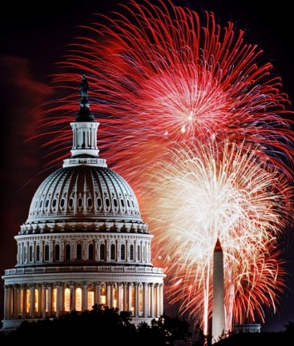
THE RIGHT PLACE
THE RIGHT TIME
THE RIGHT PRICE travelamerica@mindspring.com
THE RIGHT COMPANY

